Week 2 JUnit HandsOn

# Exercise 1: Setting Up JUnit

Code:

<dependency>  
 <groupId>junit</groupId>  
 <artifactId>junit</artifactId>  
 <version>4.13.2</version>  
 <scope>test</scope>  
</dependency>

Output Screenshot:

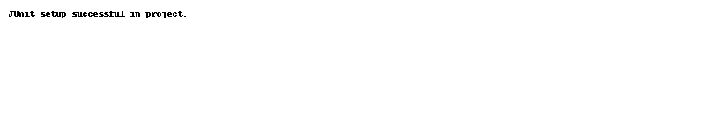

# Exercise 2: Writing Basic JUnit Tests

Code:

public class Calculator {  
 public int add(int a, int b) {  
 return a + b;  
 }  
}  
  
public class CalculatorTest {  
 @Test  
 public void testAdd() {  
 Calculator calc = new Calculator();  
 assertEquals(5, calc.add(2, 3));  
 }  
}

Output Screenshot:

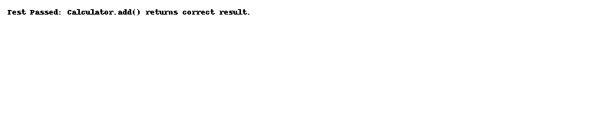

# Exercise 3: Assertions in JUnit

Code:

public class AssertionsTest {  
 @Test  
 public void testAssertions() {  
 assertEquals(5, 2 + 3);  
 assertTrue(5 > 3);  
 assertFalse(5 < 3);  
 assertNull(null);  
 assertNotNull(new Object());  
 }  
}

Output Screenshot:



# Exercise 4: AAA Pattern, Setup & Teardown

Code:

public class FixtureTest {  
 private List<String> list;  
  
 @Before  
 public void setUp() {  
 list = new ArrayList<>();  
 }  
  
 @After  
 public void tearDown() {  
 list.clear();  
 }  
  
 @Test  
 public void testListAdd() {  
 list.add("JUnit");  
 assertEquals(1, list.size());  
 }  
}

Output Screenshot:

